Mandatory Uniform Attire | Allowable Attire | Not Allowable Attire
Polo-style solid shirts  *White  *Yellow/Gold Spectrum  *Blue Spectrum  *Black | 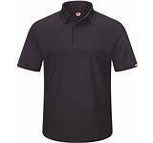 | 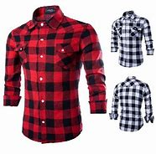
Khaki solid bottoms  *White  *Khaki (brown)  *Navy  *Black | 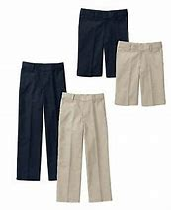 | 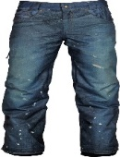
Outerwear solid sweater/hoodie  *White  *Yellow/Gold Spectrum  *Blue Spectrum  *Black | 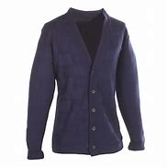 | 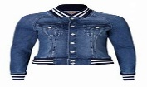
Tennis/Casual Shoes  *Entire foot enclosed  *Sandals/Flip flops are prohibited  *NO graphic socks  Students may wear closed toe Crocs or Clogs. | 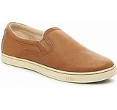 | 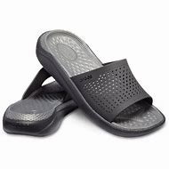
Accessories (head attire optional)  *Belts (NO sagging)  *Headbands (NO bandanas)  *HATS/VISORS are prohibited  *Backpacks (CLEAR only)  Absolutely no hoods, hats, ski masks, or bonnets. | 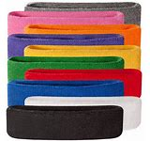 | 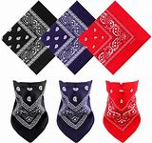
Please Be Advised:
*Uniform compliance is expected everyday upon entering the school building
*Students who arrive to school without their uniform will be redirected and re-dressed
*Students who refuse uniform policy will be required to have a parental appearance.
*HATS, BONNETS, DURAGS and SKI MASKS are PROHIBITED*All hoods are to be down in the building. HOODS AND SKI MASKS ARE A SAFETY ISSUE
Dress down days will be determined by Principal Crumble
For uniform questions/request please contact Dr. Nash and/or Ms. Burris

